1. Sebelum melakukan update periksa dulu folder aplikasi dan nama database yg di gunakan.
2. Backup DataBase

Backup/Duplicate table :

tarif => tarif_17_07_17

Poliklinik => Poliklinik_17_07_17

Komponen_tarif => Komponen_tarif_17_07_17

1. Import tarif
   1. komponen_tarif_dan_poli

klik kanan pada Database yg akan di update -> Pilih *Backup/Export ->* *Backup Database As SQL Dump..*

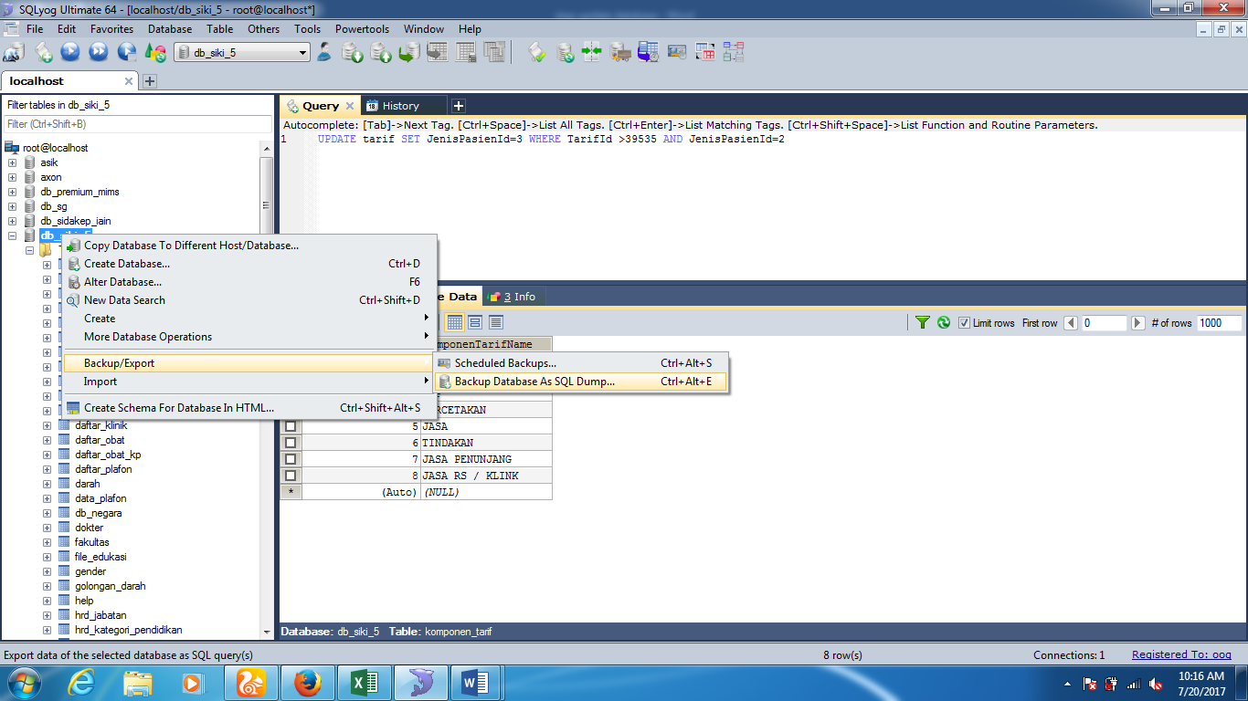

Pilih Database yang suda di download (*komponen_tarif_dan_poli_kp.sql*) -> *Open -> Yes -> Done*

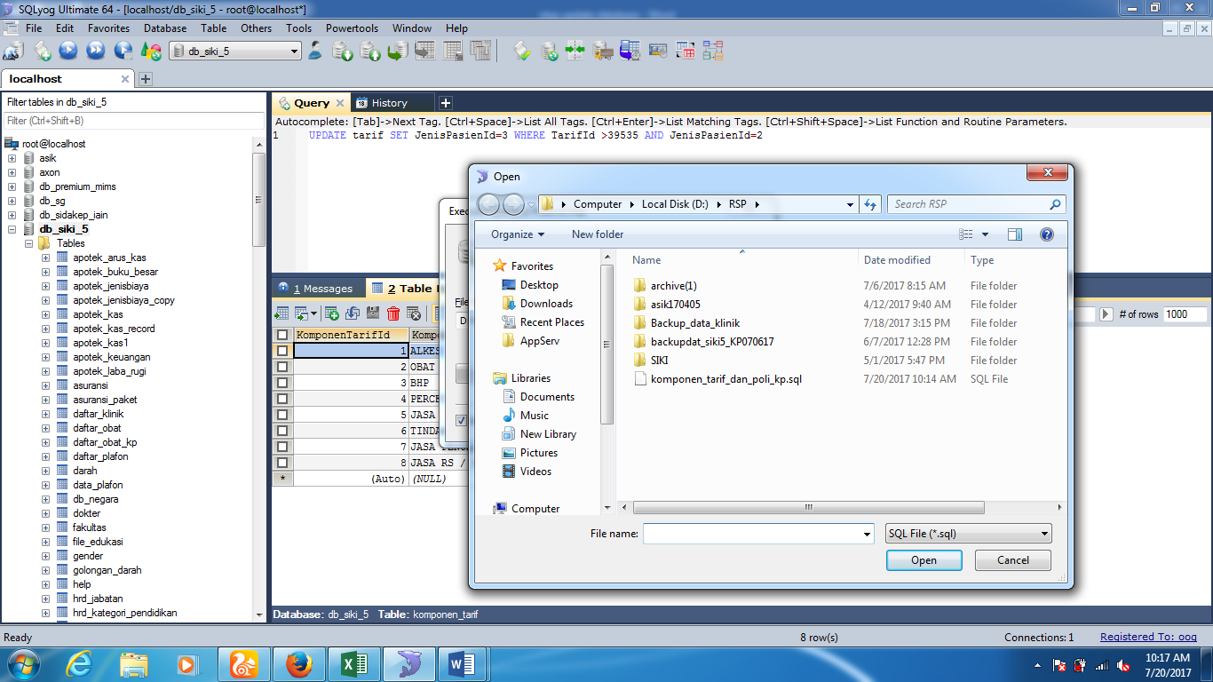

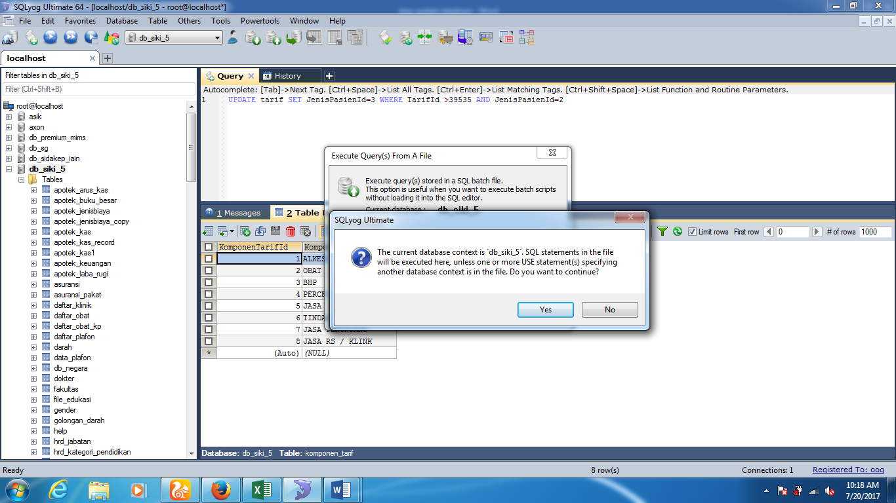

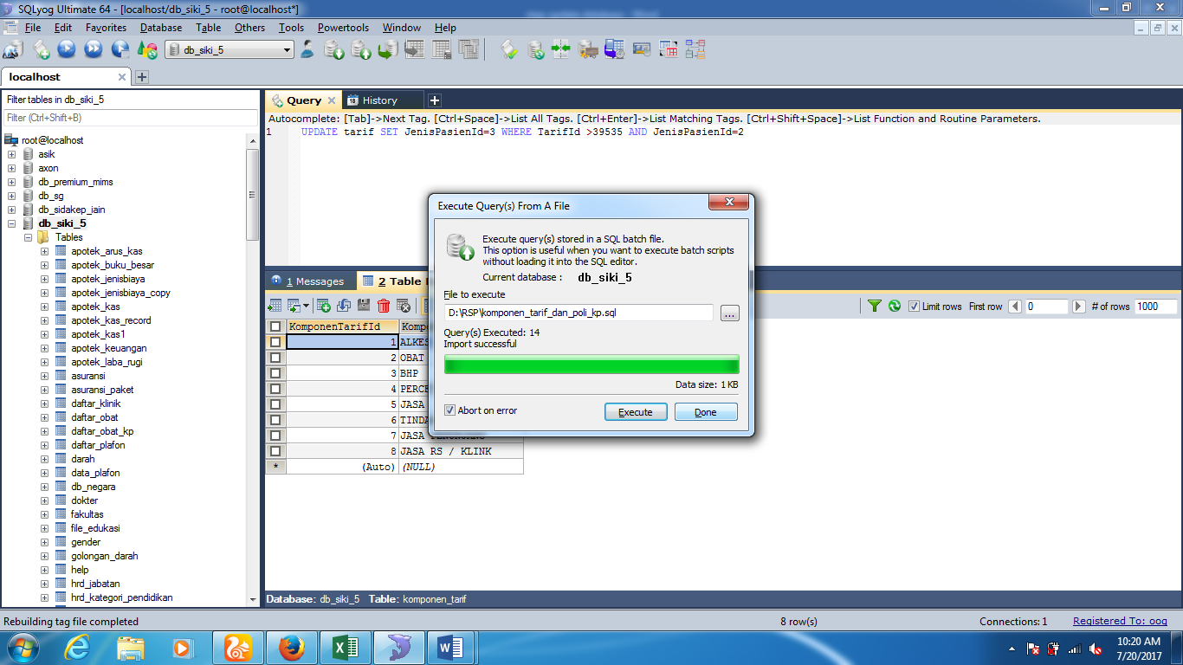

_

* 1. import tarif baru

Klik kanan pada table tariff - > Import -> import CSV Data ->import file csv yg sudah di download (Book3.csv)

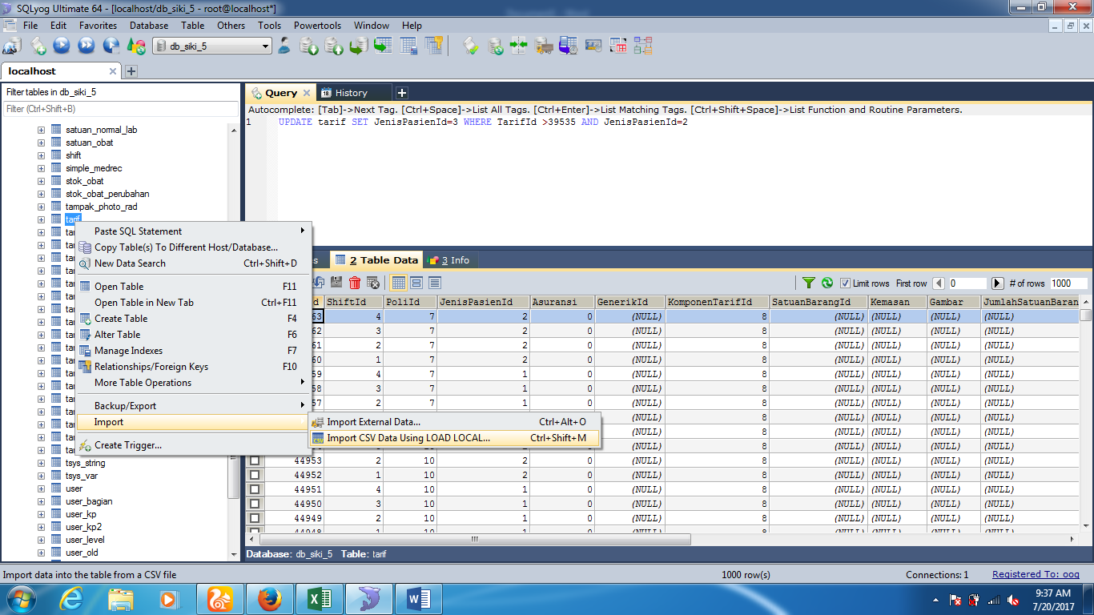

Pada area Colums pilih ShiftId,PoliId,JenisPasienId,KomponenTarifId,TarifName,Tarif

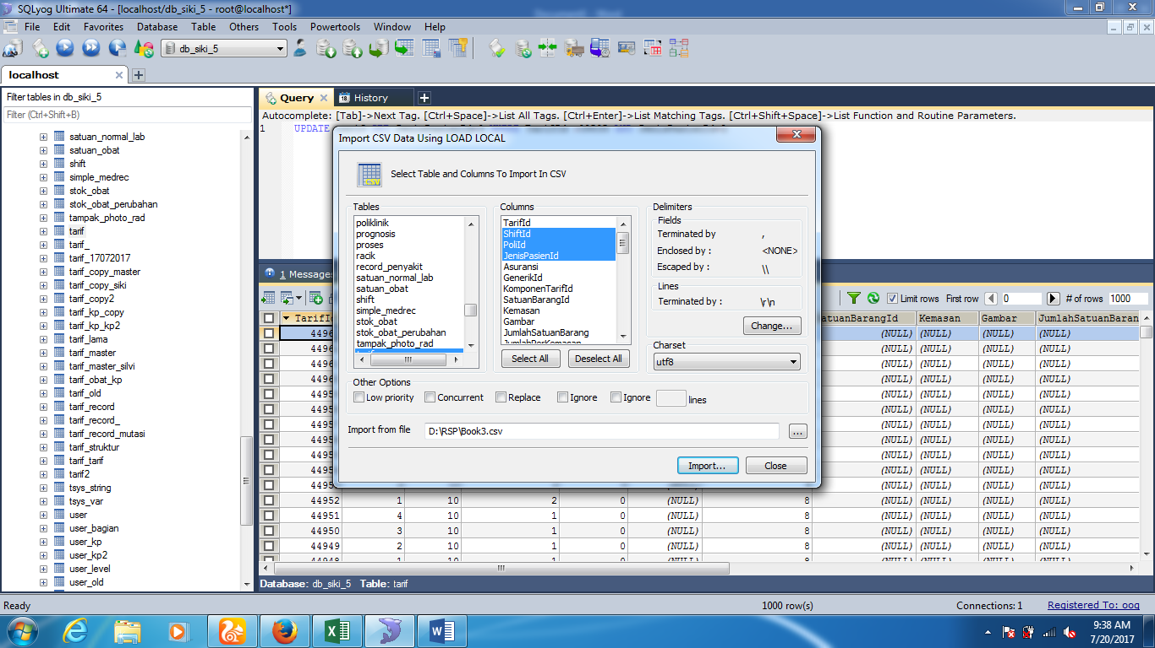

Delimeter disesuaikan gambar dibawah -> ok

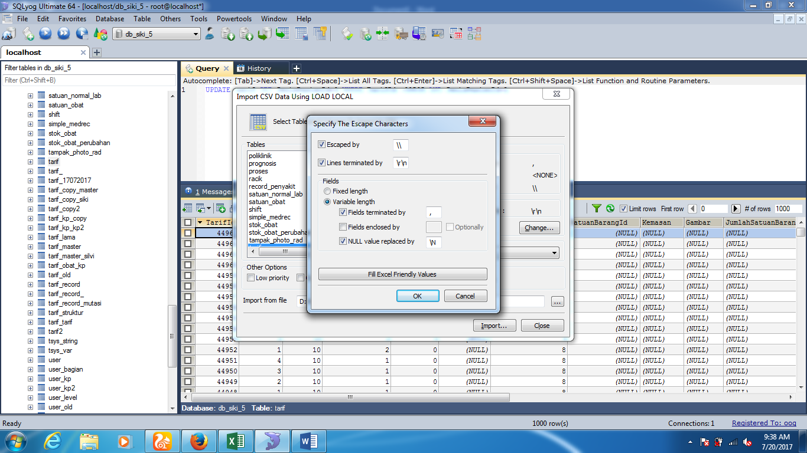

1. Update Aplikasi
   1. File tarifCustom.php yg ada pada folder autocomplete.

tambahkan script *AND TarifId >39535(idrecord terakhir pada table tarif sebelumnya jika record terahhir 39000 maka query yg ditambahkan AND TarifId >39000)*

hilangkan di query “ or jenispasienid = ‘4’ ”

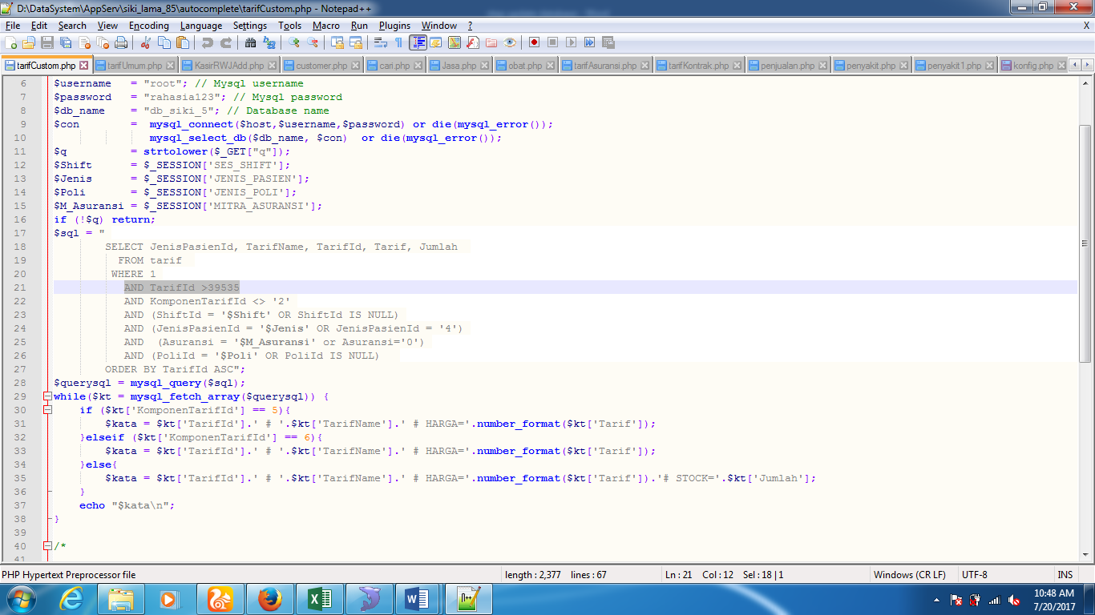

1. File incLibrary.php yg ada pada folder inc.

Update fungsi :

1. *function* *cekTarifCustomShiftUmum*

*function cekTarifCustomShiftUmum($data1,$data2,$data3,$klinik)*

*{*

*$hasil = '<option></option>'."\n";*

*$p = "select TarifId,TarifName*

*from tarif*

*where 1*

*AND TarifId > 39535*

*and PoliId = '$data1'*

*and JenisPasienId = '$data2'*

*and ShiftId = '$data3'*

*and (KomponenTarifId = '5' or KomponenTarifId = '6' or KomponenTarifId = '7' or KomponenTarifId = '8')*

*order by TarifName ASC";*

*$h = mysql_query($p);*

*while($d = mysql_fetch_array($h))*

*{*

*$pilih = '';*

*if($klinik == $d['TarifId'])*

*{*

*$pilih = ' selected="selected"';*

*}*

*$hasil .= '<option value="'.$d['TarifId'].'"'.$pilih.'>'.$d['TarifName'].'</option>'."\n";*

*}*

*return $hasil;*

*}*

1. *function cekTarifCustomShift*

*function cekTarifCustomShift($data1,$data2,$data3)*

*{*

*$hasil = '<option></option>'."\n";*

*$p = "select TarifId,TarifName*

*from tarif*

*where 1*

*AND TarifId > 39535*

*and PoliId = '$data1'*

*and JenisPasienId = '$data2'*

*and ShiftId = '$data3'*

*order by TarifName ASC";*

*$h = mysql_query($p);*

*while($d = mysql_fetch_array($h))*

*{*

*$pilih = '';*

*if($klinik == $d['TarifId'])*

*{*

*$pilih = ' selected="selected"';*

*}*

*$hasil .= '<option value="'.$d['TarifId'].'"'.$pilih.'>'.$d['TarifName'].'</option>'."\n";*

*}*

*return $hasil;*

*}*

1. *function cekTarifCustomAsuransiSelect*

*function cekTarifCustomAsuransiSelect($data1,$data2,$data3,$data4,$klinik)*

*{*

*$hasil = '<option></option>'."\n";*

*$p = "select TarifId,TarifName*

*from tarif*

*where 1*

*AND TarifId > 39535*

*and PoliId = '$data1'*

*and JenisPasienId = '$data2'*

*and ShiftId = '$data3'*

*and (Asuransi = '$data4' OR Asuransi ='0')*

*and (KomponenTarifId = '5' or KomponenTarifId = '6' or KomponenTarifId = '7' or KomponenTarifId = '8')*

*order by TarifName ASC";*

*$h = mysql_query($p);*

*while($d = mysql_fetch_array($h))*

*{*

*$pilih = '';*

*if($klinik == $d['TarifId'])*

*{*

*$pilih = ' selected="selected"';*

*}*

*$hasil .= '<option value="'.$d['TarifId'].'"'.$pilih.'>'.$d['TarifName'].'</option>'."\n";*

*}*

*return $hasil;*

*}*

1. *function cekTarifTindakanMusking.*

*function cekTarifTindakanMusking($data1,$JP,$Shift,$Poli,$Medrec)*

*{*

*$hasil = '<option></option>'."\n";*

*if ($JP ==1 )*

*{*

*$PencarianData ='';*

*}*

*else*

*{*

*//$MitraAsuransi = tampilPasienCustom('MitraAsuransiId',$Medrec);*

*//$PencarianData = "AND Asuransi='$MitraAsuransi'";*

*$PencarianData ='';*

*}*

*if ($Poli==29)*

*{*

*$Poli=6;*

*}*

*elseif ($Poli==27 or $Poli==28)*

*{*

*$Poli=1;*

*}*

*$p = "select TarifId,TarifName, SatuanBarangId*

*from tarif*

*where 1*

*AND TarifId > 39535*

*and (KomponenTarifId = '6' or KomponenTarifId = '7')*

*AND (PoliId = '$Poli' or PoliId ='7' or PoliId ='8')*

*AND ShiftId = '$Shift'*

*AND JenisPasienId = '$JP'*

*".$PencarianData."*

*order by TarifName ASC";*

*$h = mysql_query($p);*

*while($d = mysql_fetch_array($h))*

*{*

*$pilih = '';*

*if($klinik == $d['TarifId'])*

*{*

*$pilih = ' selected="selected"';*

*}*

*$hasil .= '<option value="'.$d['TarifId'].'"'.$pilih.'>'.$d['TarifName'].' # UNIT : '.tampilSatuanBarang($d['SatuanBarangId']).'</option>'."\n";*

*}*

*return $hasil;*

*}*